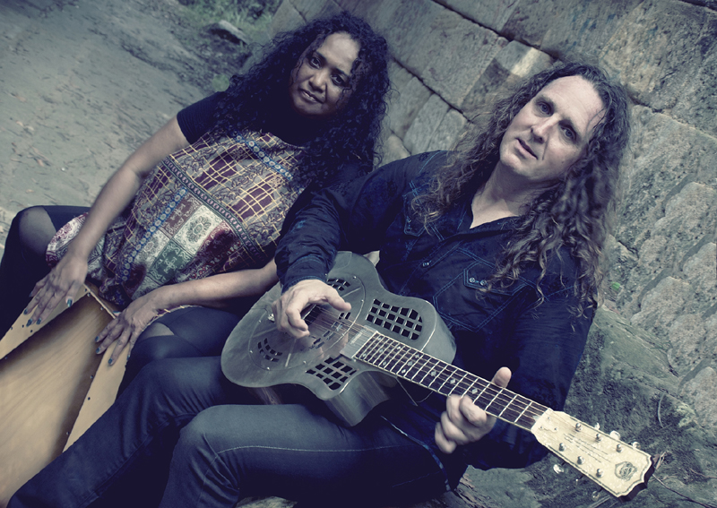
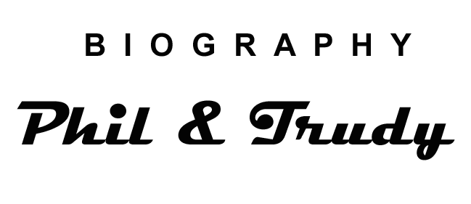

Phil Edgeley is an English born singer/songwriter who now resides in Australia. His music draws influence from Delta Blues masters such as Robert Johnson, Fred McDowell and Skip James, contemporary artists such as Chris Whitley, Jeff Lang and Chris Smither and, of course, from his English background, taking in the styles of Richard Thompson, John Renbourn, Jimmy Page and Robert Plant. His lyrics deal with the multi-facets of life, often pulling no punches and delivered in a direct fashion but still somehow emotive and thought provoking rather than hard. Phil spent several years touring as a solo artist and has released 3 albums to date, “This Life” (2005) “Then and Now” (2007) and “In the Blood” (2011). Harmonica icon Jim Conway desribes Phil as a.."Masterful guitarist and songwriter who performs with great heart and passion.”

Now add Trudy Edgeley, an Australian Singer Songwriter, hailing from a rich musical background founded in both her family's strong Gospel lifestyle and her rich heritage, which is a melting pot of cultures including Solomon Islands, Jamaican, Irish and Indigenous Australian. She was drawn into performing at an early age following her Father's footsteps into the Church choir, and then quickly forging a reputation for performing solo with her guitar at many religious gatherings over the following years. Aside from the religious influences, and, on account of growing up in a large family, Trudy was also exposed to a kaleidoscope of music ranging from Bessie Smith and Carole King onto Neil Young and Bob Dylan to name a few. Trudy creates a blend of vocals and a sound that reflects not only her influences and passion for her music, but also her desire to tell the stories of her rich ancestery. This results in well crafted songs that have the added interest of fascinating stories which have been seldom told.

Despite perfoming many shows together in earlier years Trudy's commitments shifted to successfully managing Phil's solo persuits. This continued until a chance “jam session” one day in Queensland when it became very apparent that Trudy could no longer ignore the desire from deep down in her blood to start performing once again. In 2012 The Duo act “Phil & Trudy Edgeley” was born. Phil's British Folk/Blues songwriting & musical style has now been infused with Trudy Edgeley's tropical tempos, melodies and haunting vocals to create a new sound and also a new album “Oneplusoneequalsthree” (2014). This is their debut duo album, so titled after repeated comments from audiences that it is difficult to believe that so much sound can come from just two people, it is already receiving comments along the lines of, “great variation of tracks” “packed with energy” and “impressive songwriting”.

On the road to producing this album Phil & Trudy Edgeley have been criss-crossing the continent over the past few years carving out their way as a genuine musical force. They have systematically earnt themselves a reputation for creating striking original material and delivering shows which are not only drenched in power and dynamics but still manage to be soulful and sensitive. The songs, which are a result of the infusion of cultures and influences, produce a musical experience that is both captivating and intriguing.

With the vast experience gained from performing together throughout the UK, Europe and the USA, Trudy and Phil encapsulate the dynamics of a great partnership on both a musical and a personal level. Throw in a little humour and interaction with the audience and the result is a show that draws the listener into a new and exciting place.

Audiences say... “Phil and Trudy Edgeley, hard to define? ...yes, worth further investigation? ...Absolutely!”

Phil and Trudy Edgeley have created a magical brew of Folk, Blues and Roots. They have weaved their musical spell to tremendous acclaim across Australia, the UK, Europe and the USA. Their performances are authentic conversations, stemming from heavy roots set deep in fertile soil. We were first enlightened to Phil’s astounding skills as a singer/songwriter/guitarist through his previous canon of tour de force albums, launched in two yearly intervals over the past decade. Now adding Trudy’s sublime percussion to the mix there is a tangible synergy – their debut album is suitably titled “1 + 1 = 3”. In live performance you can hardly believe your ears, with Trudy’s world music influenced patterns within patterns sometimes achieved seemingly by sleight of hand. The alchemy we witnessed at their September 2014 Sydney gig was the purest playing we have heard in ages. In our experience, that kind of ‘third-eye’ subtle yet complex interplay is only possible when performing partners are also life partners. The Phil and Trudy Edgeley experience is one that transcends music into both a gentle reflection and passionate celebration of Life – wondrous and earthy narratives evoked with fire and grace. This is one of the great musical experiences Australia has to offer.’ - Tim Huang & Calvin Welch – iHearMusic.com

“Phil and Trudy combine Blues & Roots with rhythmic patterns to make a powerful feast for the ears” - Australian Blues master Brian Fraser

"Who'd have thought that a tributary of the mighty Mississippi managed to wind its way through Lincolnshire, or to be precise, tiny Rutland, and deposited such a rich vein of Delta-soaked blues in the heart of one of its gypsy musician sons. Well, Phil Edgeley is the proof that the blues knows no colour, only the passion to express itself with honesty and integrity - and a cheeky grin!" - Michael Smith, Drum Media

"Masterful guitarist and songwriter who performs with great heart and passion" - Jim Conway

Festivals to date... Supports to date...
Thredbo Blues Festival (2015) Russell Morris
Airlie Beach Music Festival (2013) Ian Moss
Cairns Folk 'n' Roots (Cairns Festival 2012) Tex Perkins
Darwin Blues Festival (2012) Jeff Lang
The Blues Train, Queenscliffe (2012) Ash Grunwald
River of Art Moruya (2010, 2011) The Backsliders
Thredbo Blues Festival (2010, 2011) Bondi Cigars
Howden RibFest (UK) (2009) Eugene “Hideaway” Bridges (USA)
Illawarra Folk Festival (2009) Andrew Winton
Central Coast Blues Festival (2009) Glen Terry
Railway Blues Festival (2009) The Stiff Gins
Nimmitable Blues Festival (2008) The Spikedrivers (UK)
Davistown Blues Festival (2008)
Newcastle Blues Festival (2004, 2005, 2007)
Port Stephens Whales & Blues Festival (2007)
CoastFest (2007)
Mattara Festival (2006)
St Albans Folk Festival (2003, 2005)
Berry Blues Festival (2003, 2004)
Manly Folk Festival (2003)

Email address: philandtrudyedgeley@bigpond.com / mobile 0419 445 765
www.philandtrudyedgeley.com

